The Golden CSR of a Moravian Company

CSR (Corporate Social Responsibility) is a very current and highly debated subject in recent years.
The Moravian company Avex Steel Products s.r.o. from Otrokovice is aware of its obligation arising from its business and fully takes responsibility for its actions both with regards to the environment and also to society.
In a long-term perspective, the company acts as transparently as possible in all areas of its business and therefore gains credit for its character, credibility and even its profitability.
Thanks to its long-lasting work and fair play, the company can now boast 2 golden CSR medals (2017, 2018) which ranks them among the world’s elite companies.
“We rank among the TOP 5% of companies in the world in our field and we are proud of it. We do not just focus on production and sales as we also care about our effect on other companies, the environment and work conditions. Despite all of the awards which we are very proud of, we do not intend to rest on our laurels. Continuous improvement is our goal.
For example, to lower the dustiness in our production halls, we use a secondary wastewater separator and such solutions not only make the work environment as well as employees healthier but also reduce the company’s ecological footprint. And because not everyone can be as lucky as us, we focus our efforts also on projects of a charitable nature.
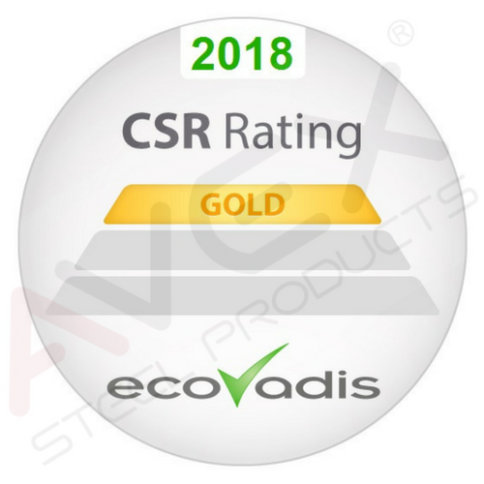
Yes, we are industrial engineers and steel runs in our veins but our hearts are in the right place,” Jiří Gistr, the company’s owner, adds.

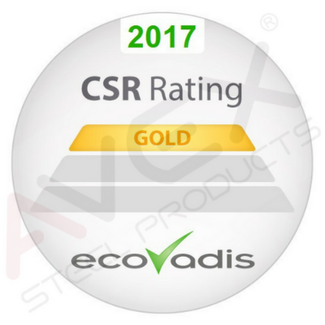

Note:

ECOVADIS of France was the evaluating firm which operates the first platform for providing evaluations of global supply chains. It has a team of 400 professionals from 40 different nationalities and combines their professional knowledge of the CSR field with advanced technology. It can supply a complex CSR evaluation which helps in making essential changes to supply chains around the world such as Nestlé, Johnson & Johnson, Salesforce, Coca-Cola Enterprises, Nokia, L´Oreal, Bayer, Subway, ING Bank, Air France – KLM, BASF and more. More than 35,000 companies use the Ecovadis system for the lowering of risks, innovations and the support of transparency and trust between business partners.
The evaluation of an organization takes place based on the following principles:
- 9 principles of the GLOBAL COMPACT initiative created and started by Kofi Annanem (OSN)
- EU Green Papers
- GRI (Global Reporting Initiative)
Basic Evaluation Pillars:
- economics
- ecology
- social responsibility

